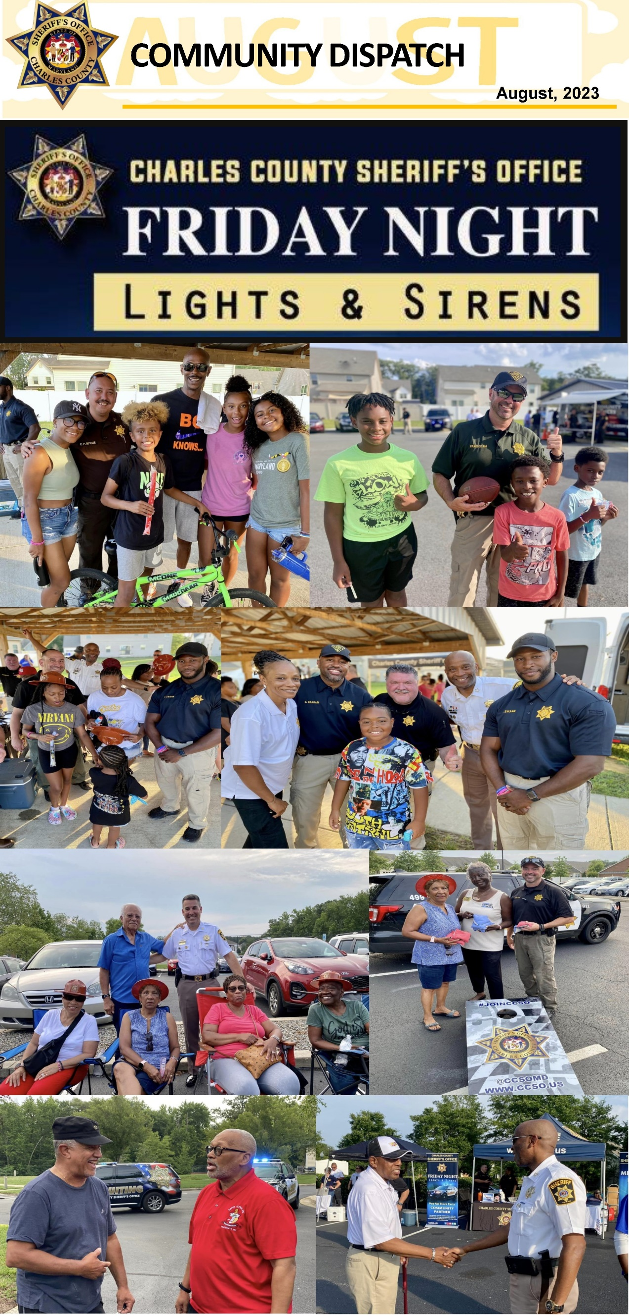

Thank you to the Worthington and Heritage at St. Charles neighborhoods for allowing us to host CCSO's Friday Night Lights and Sirens Block Parties at their communities. We had great turnouts! Thank you for making these events successful. We appreciate your support and partnership.

COMMUNITY DISPATCH

August 2023

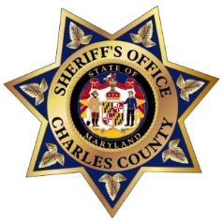
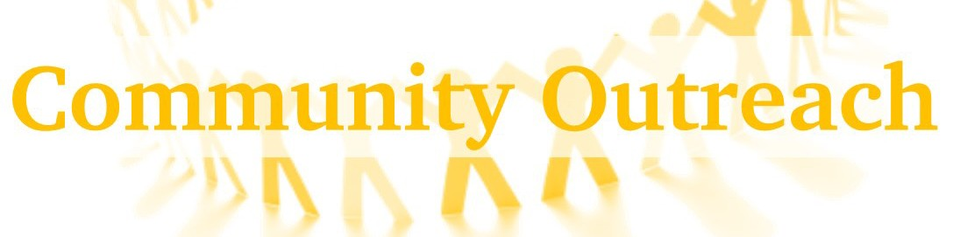
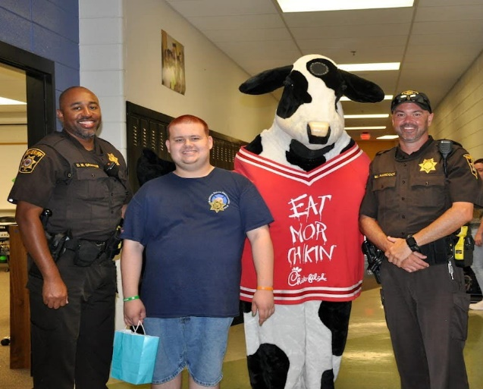
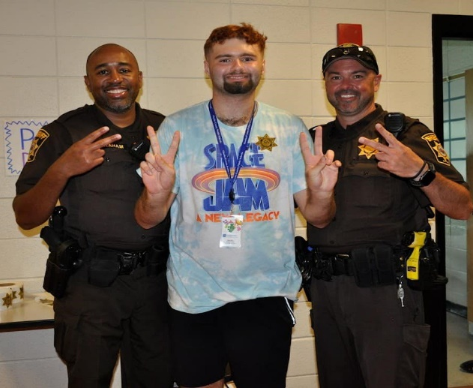
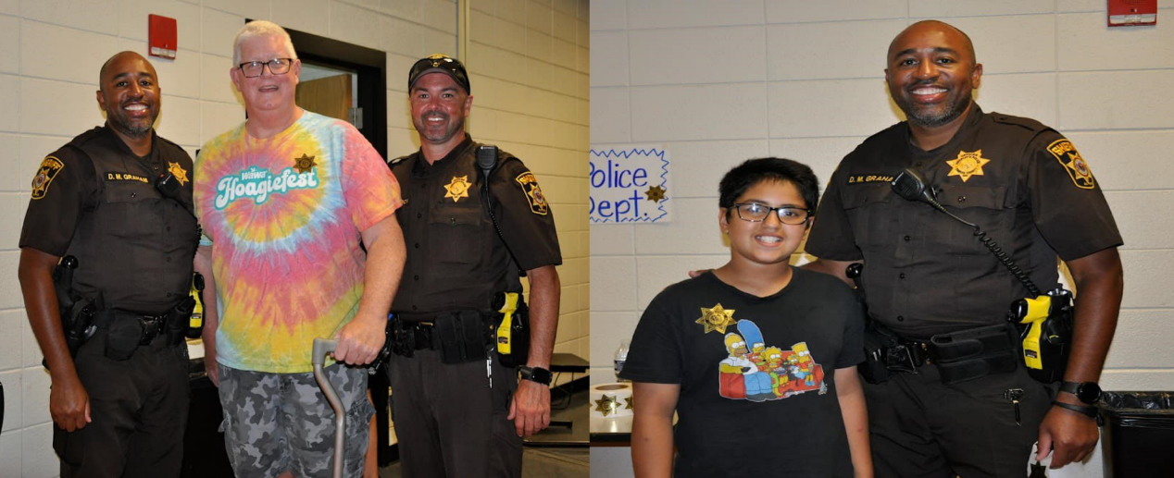
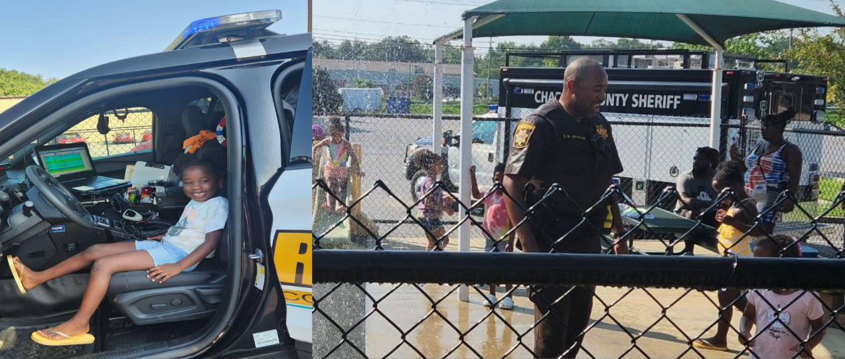
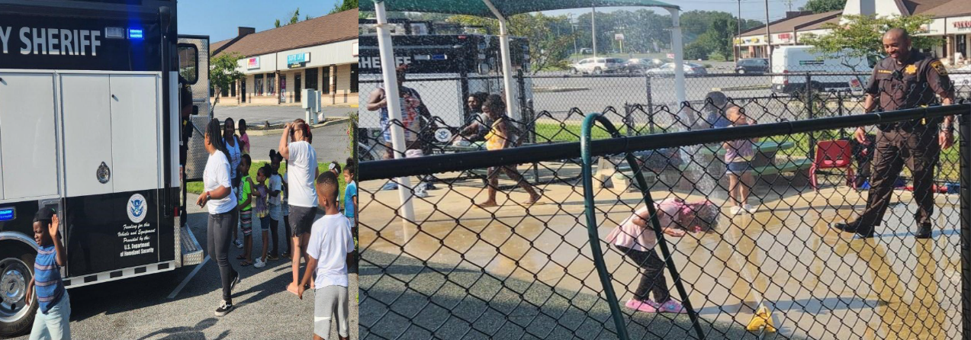

Thank you to Charles County Parks and Recreation for inviting us to their Camp Co-Op event, held at North Point High School. This camp is held for those in our community with physical and intellectual disabilities. Officers Graham and Hancock with the CCSO Community Engagement Unit, assisted campers as they participated in games and other fun events. We are honored and proud to have helped!

What a fun day, for officers Graham and Wagner assigned to the Community Engagement Unit! They conducted a safety talk with the wonderful students at the J. Woodhall Head Start Center in White Plains. At the conclusion of the talk, Officer Graham joined in for a little fun water play, creating lots of laughter! The Community Engagement Unit continuously works toward building relationships with youths!

COMMUNITY DISPATCH

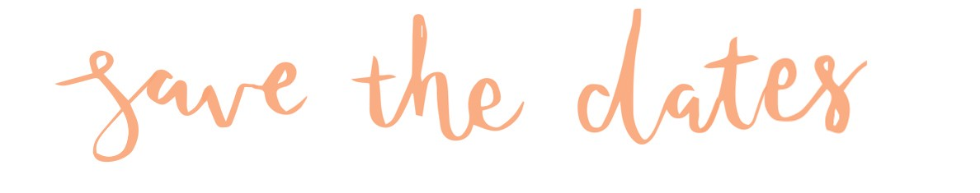
August 2023

2023 Charles County Fair

September 14-17, 2023

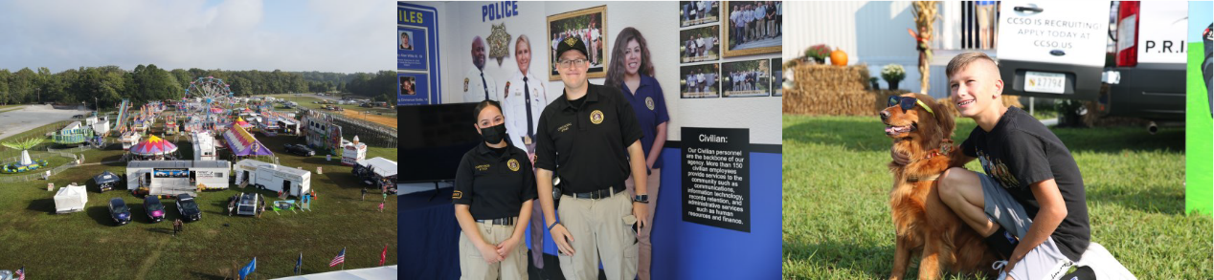

2023 Charles County Sheriff’s Office Trunk or Treat Event

October 26, 6 p.m. - 8 p.m.

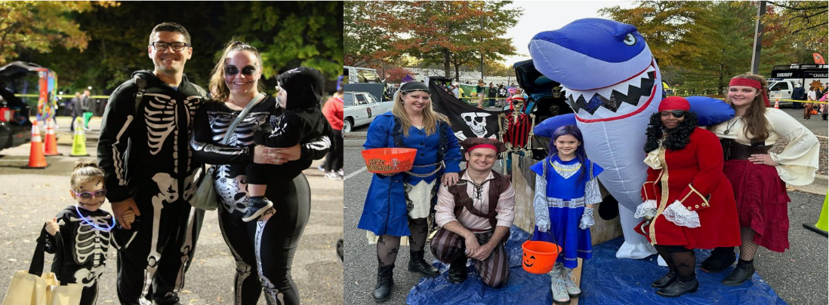

Please join us for the 2023 Charles County Fair and our third annual Charles County Sheriff’s Office Trunk or Treat event! We love seeing and interacting with our communities! Additional details will be forth coming in regards to the Trunk or Treat event as
We get closer!

The Business Watch Program is designed to enhance the communication between businesses and the Charles County Sheriff’s Office. The purpose of the Business Watch Program is to support businesses through proactive collaborative efforts to actively reduce and prevent crime impacting the business community, using communication, education, and enforcement. Information regarding current crime trends and crime prevention tips will be sent through an e-mail chain from the Charles County Sheriff's Office Community Engagement Unit to the business owners and business supervisors who wish to participate. To register your business please contact the Community Organizer at
proctora@ccso.us/ 301-932-3080.

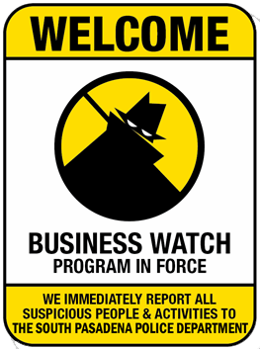
TRAFFIC COMPLAINT LINE: 301-932-3062 or trafficoperations@ccso.us

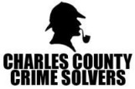
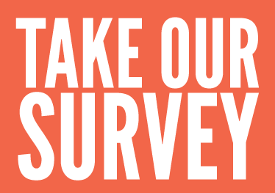

Questions, comments, complaints?
Please contact our Civilian Community Coordinator
Mr. Gus Proctor: (301) 932-3080 proctora@ccso.us

