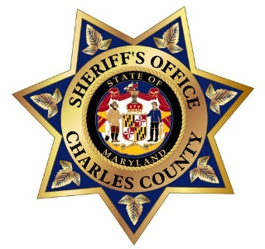

NATIONAL NIGHT OUT
TUESDAY AUGUST 2, 2022
REGISTRATION FORM

NEIGHBORHOOD: Click or tap here to enter text.
CONTACT PERSON: Click or tap here to enter text.
ADDRESS: Click or tap here to enter text.
CELL PHONE #Click or tap here to enter text. Email Address: Click or tap here to enter text.
DIRECTIONS TO CELEBRATION SITE: Click or tap here to enter text.
START TIME: Click or tap here to enter text. END TIME: Click or tap here to enter text.
NUMBER OF EXPECTED PARTICIPANTS: Click or tap here to enter text.
DESCRIPTION OF PLANNED ACTIVITIES: Click or tap here to enter text.

COMPLETE FORM AND MAIL, EMAIL OR FAX TO:
Mr. Gus Proctor #1924 (Retired)………..proctora@ccso.us
P.O. BOX 189, LA PLATA, MD 20646
FAX: 301-609-3258
NEED ADDITIONAL INFORMATION: 301-932-3080

PLEASE RETURN FORM BY JULY 1st 2022
This will allow us time to schedule our Officers and McGruff.

