Ladies Leadership
Soccer Camp
2018

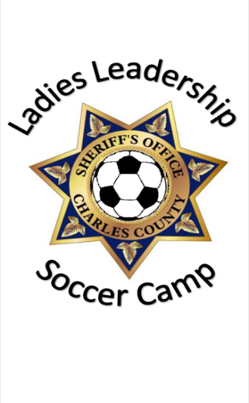

Sponsored by Waldorf Jaycees and Charles County Public Schools

LADIES LEADERSHIP SOCCER CAMP

Join the Charles County Sheriff’s Office School Resource Officers for

3 days of soccer training, to include skills on passing, dribbling, and

shooting. Participants will scrimmage other teams and have classroom

Instruction on teamwork, sportsmanship and leadership.
CAMP INCLUDES: Details: June 20th, 21st, and 22nd
Lunch (All Three Days) 9am -2pm Soccer Camp T-Shirt Laurel Springs Park Leadership Education by Ages 7-10 CCSO School Resource Officers Limited to first 65 registrants
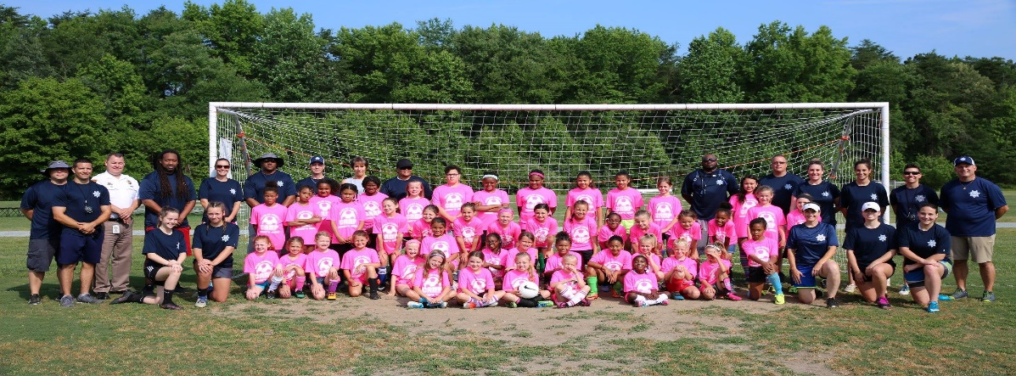
Charles County Residents Only!!!

LADIES LEADERSHIP PARTICIPANT INFORMATION
Child’s Name_______________________________________ Age__________
T-Shirt _____________________* Please specify youth or adult size S, M, L, or , XL.
CONTACT INFORMATION
Parent/Guardian Name______________________________________________________________________________ Address______________________________City______________________ State______ Zip___________ E-mail_________________________________________Phone Number___________________________

ALL COMPLETED FORMS MUST BE RETURNED TO A SCHOOL RESOURCE OFFICER.
THIS IS A FREE CAMP!!!

