Kids and Kops Football Camp

PRESENTED BY THE
CHARLES COUNTY SHERIFF’S OFFICE
CHARLES COUNTY PUBLIC SCHOOLS
WALDORF JAYCEES
CAL RIPKEN SR. FOUNDATION

JULY 5-6, 2018
9 A.M. TO 2 P.M.
ST CHARLES HIGH SCHOOL
CURRENT STUDENTS IN GRADES 3 -5
LIMITED TO THE FIRST 80 REGISTRANTS

Join the Charles County Sheriff’s Office for the 2018 Football Camp funded by the Waldorf Jaycees and the Cal Ripken, Sr. Foundation. Students will learn football techniques and lessons in sportsmanship and teamwork. The camp is FREE.
CAMP INCLUDES:
- Football instruction, exercises and a championship game

- Lunch

- A commemorative T-shirt

- Character education including lessons in sportsmanship and teamwork

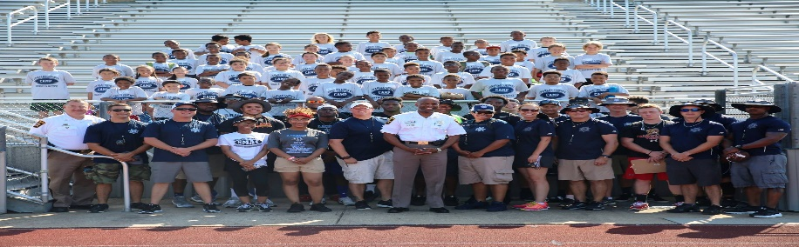

FOOTBALL CAMP PARTICIPANT INFORMATION
Child’s Name_______________________________________ Age__________ T-Shirt Size*_______________________
Childs’s School ____________________________________ Please circle: youth or adult AND size S, M, L, or , XL

CONTACT INFORMATION
Parent/Guardian Name______________________________________________________________________________
Address________________________________________ City______________________ State______ Zip___________
E-mail_____________________________________________________________ Phone Number__________________
Emergency Contact Name_____________________________________________ Phone Number__________________
**Registration will not be accepted without the required attached medical forms completed**

ALL COMPLETED FORMS MUST BE RETURNED TO A SCHOOL RESOURCE OFFICER
FOR MORE INFORMATION PLEASE CALL PFC THOMPSON AT 301-638-0858 OR CPL MANN AT 301-753-2090.

